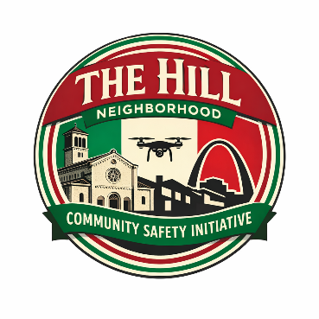
Frequently Asked Questions
The Hill Neighborhood Community Safety Initiative
What are the details of the program?
The Hill Neighborhood Community Safety Initiative is a nonprofit, community-based neighborhood safety program that uses drone technology to help deter crime, improve situational awareness, and support emergency response efforts in The Hill neighborhood. The program is designed to support public safety while maintaining strong privacy protections and clear operating rules.

Why is the neighborhood using drones?
The drones are part of the overall safety and security program which includes the block captain program, street patrols by Campbell Security and drones monitored by Titan Protection.

The program was created to help:
- Deter crime in public areas
- Improve awareness during higher-risk time periods
- Assist during emergencies or public safety incidents
- Support overall neighborhood safety and community well-being

The drones are intended to serve as a visible deterrent and an additional safety tool — not as a system for constant surveillance.

Is this legal?
Yes. All drone operations will comply with:
- Federal Aviation Administration (FAA) regulations
- Applicable state and local laws, including St. Louis Ordinance 71813

Where will the drones fly?
Drone operations are limited to:
- Public streets
- Alleys
- Sidewalks
- Other publicly visible spaces

Flights will primarily occur during the overnight hours associated with increased crime risk. Flight paths will vary and are not designed to focus on any one property or resident.

Can drones monitor my home, backyard or private property?
No. The program does not target private property or conduct surveillance of private spaces. Drones may incidentally observe areas visible from public airspace, similar to what could be seen from a public street or sidewalk, but operators are instructed to avoid unnecessary observation of private areas.

Is this connected to law enforcement?
The initiative is community-based and independently operated. However, footage may be shared with law enforcement as needed.

Are my tax dollars being used to support this program?
No. This program is being funded by private donations and community partners. Zero tax dollars will be used to fund drone operations or equipment.

Who oversees this program?
The drone is monitored and operated 24/7, 365 days a year by Titan Protection. The Safety and Security committee comprised of members of The Hill 2000 Neighborhood Association, The Hill Business Association and the Block Captain Program and work closely with Titan Protection and Campbell Security.

What type of drones are being used and who operates them?
The Hill Neighborhood Community Safety Initiative has contracted with Titan Protection, a Kansas City-based security company, to operate and pilot the drones. Drone pilots operate from Titan’s Five Diamond UL-listed Remote Operations Center (ROC), which meets rigorous national standards for safety, reliability, and operational resilience. All drone operations are conducted by trained and authorized pilots operating under established safety and privacy procedures.

